Ex.no:6 | DATA VISUALIZATION USING POWER BI

Aim:
To Load the data into PowerBI and transform the data and visualize it to get insights

Algorithm:

Algorithm: Sales Dashboard Calculation
Step 1: Input Data Loading
- Read the dataset from datas.csv containing columns Product, Region, and Sales.
- Dataset rows:
  - Laptop, North, 50000
  - Mobile, South, 35000
  - Printer, East, 25000
  - Laptop, West, 45000
  - Mobile, North, 40000
  - Printer, South, 30000
Step 2: Region Filter Check
- Check slicer selection for Region.
- Default selected regions: East, North, South, West.
- Retain all rows matching the selected regions in Filtered_Data.
Step 3: KPI Total Sales Calculation
- Sum all values in the Sales column from Filtered_Data.
- Total Sales = 50000 + 35000 + 25000 + 45000 + 40000 + 30000 = 225000 (displayed as 225K).
Step 4: Bar Chart Calculation (Sum of Sales by Product)
- Group Filtered_Data by Product and sum Sales for each product:
  - Laptop Sales = 50000 (North) + 45000 (West) = 95000
  - Mobile Sales = 35000 (South) + 40000 (North) = 75000
  - Printer Sales = 25000 (East) + 30000 (South) = 55000
- Sort products in descending order by total sales: Laptop, Mobile, Printer.
Step 5: Donut Chart Calculation (Sum of Sales by Region)
- Group Filtered_Data by Region and sum Sales for each region:
  - North Sales = 50000 + 40000 = 90000
  - South Sales = 35000 + 30000 = 65000
  - West Sales = 45000
  - East Sales = 25000
- Calculate percentage share for each region relative to Total Sales (225000):
  - North Share = (90000 / 225000) * 100 = 40.00%
  - South Share = (65000 / 225000) * 100 = 28.89%
  - West Share = (45000 / 225000) * 100 = 20.00%
  - East Share = (25000 / 225000) * 100 = 11.11%
Step 6: Dashboard Render
- Render KPI card with formatted total value 225K.
- Render vertical bar chart with Laptop at 95K, Mobile at 75K, Printer at 55K.
- Render donut chart with region segments North (90K, 40%), South (65K, 28.89%), West (45K, 20%), East (25K, 11.11%), and center value 225K.
- Render region slicer checkboxes for East, North, South, West.
- On slicer selection update, filter rows and recompute steps 2 through 6.

Output:
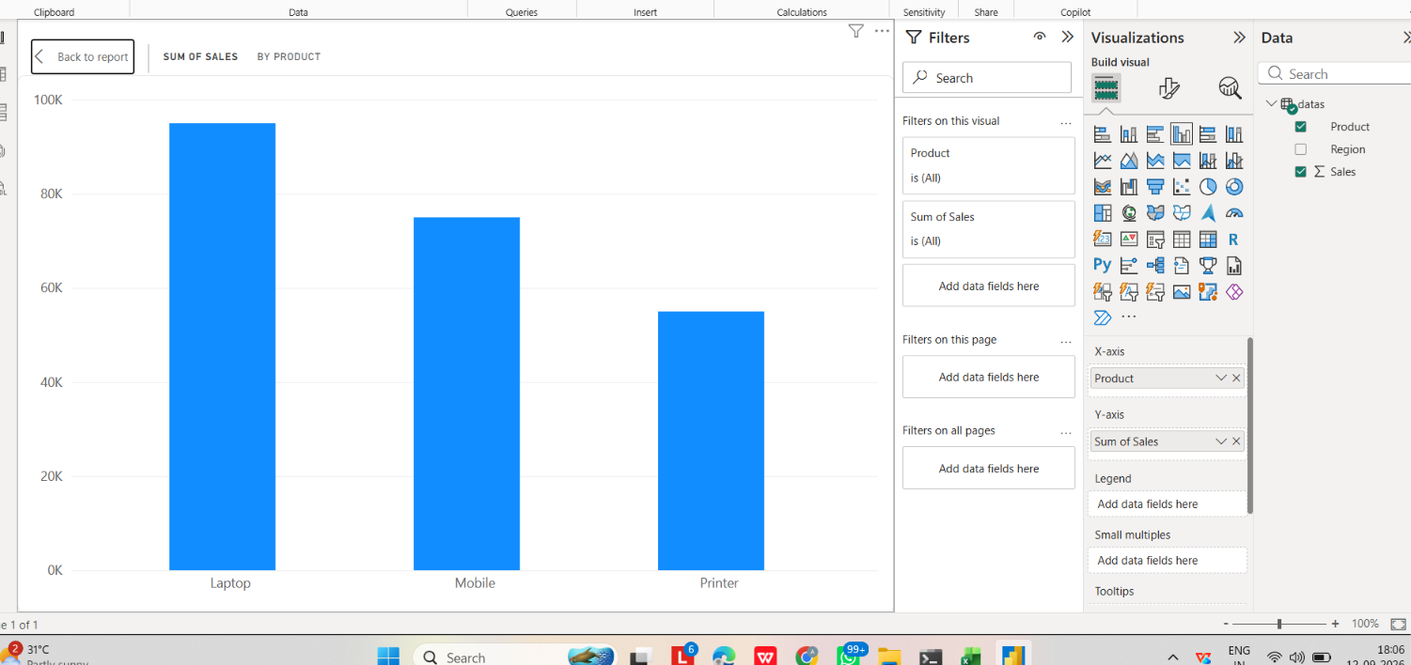
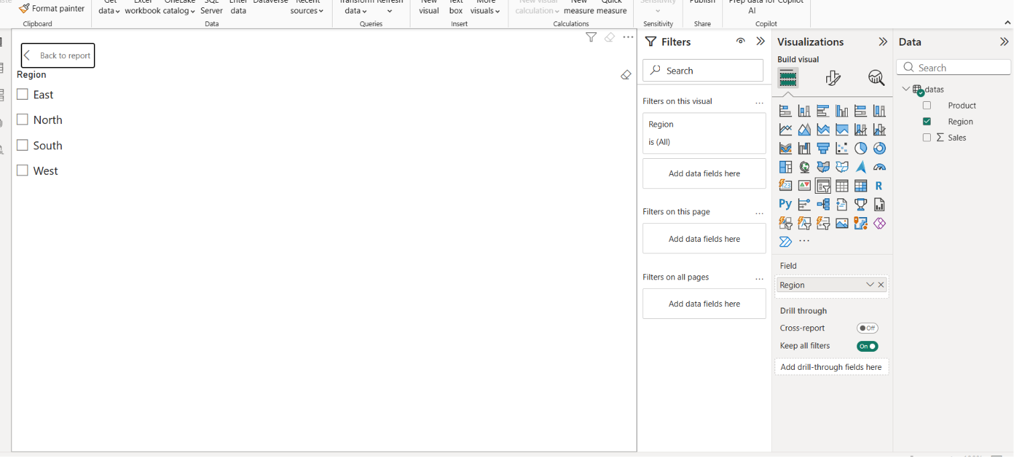

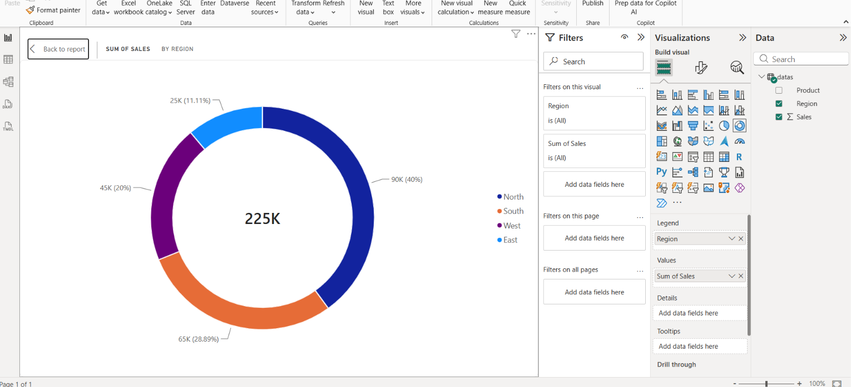
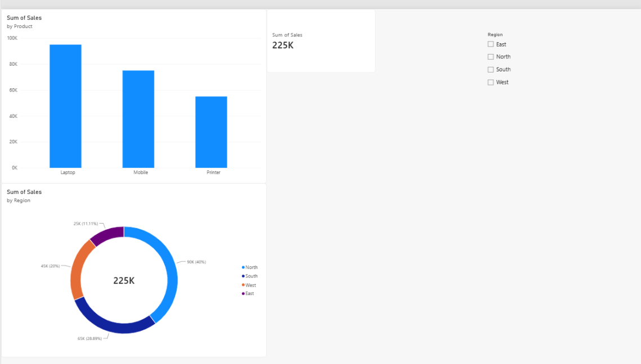

Result:
Thus, the sales data was successfully imported into Power BI and transformed for analysis. A Sales Dashboard was created using a Column Chart to visualize product-wise sales, a Card to display total sales, a Donut Chart to show region-wise sales distribution, and a Slicer to interactively filter the dashboard based on regions. The dashboard successfully provided meaningful insights into the sales performance.

